21st ANNUAL
EAST-WEST NORRITON FIRE COMPANIES
GOLF OUTING

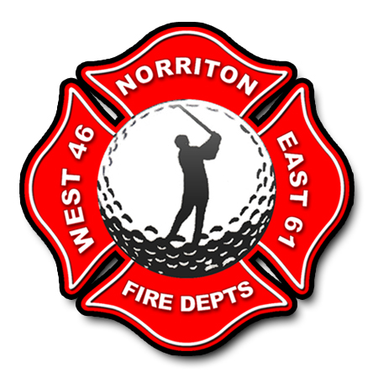

SATURDAY AUGUST 10, 2024
JEFFERSONVILLE GOLF CLUB
2400 W. MAIN ST

12:30 p.m. Check -In
1:30 P.M. SHOTGUN START

$100 PER PLAYER

GOLF-FOOD-PRIZES

MAKE CHECKS PAYABLE TO: JEFFERSON FIRE CO NO 1.

